THE MATTHEW PROJECT
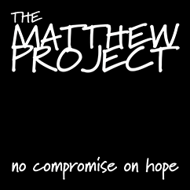

UNITY

Drug and Alcohol Service for children, young people under 19 and their families across Norfolk.
We offer support to young people who are using drugs or alcohol themselves and those who are affected by someone else's use.
We have workers based across the county in Kings Lynn, Great Yarmouth and Norwich and workers can visit families or young people anywhere in Norfolk.
The services also provides advice and consultation for professionals working with children and young people.
Referral Process

Refer by telephone on 01603 216420.

Location

Unit 8, Gateway, 83-87 Pottergate, Norwich, NR2 1DZ

Contact Details

Office: 01603 216420
Advice Line: 0800 970 4866

ON TRACK
The Matthew Project is the lead partner for On Track, the Building Better Opportunities service for 16-24 year olds in Norfolk.
The new service is to help young people get into work, education or training.
On Track is different because it is tailored to meet your needs.
Our friendly coaches and mentors will support you all the way. They will give you the advice and help you need to make the most of the things you are good at.
And it's completely free.
Location

Nedeham House, 22 St Stephens Road, Norwich, NR1 3QU

Contact Details

On Track - 01603 723845 / contact@ontracknorfolk.org

