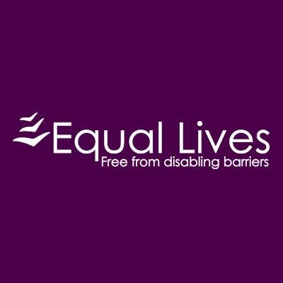
Equal Lives

Service

Equal Lives provides information and advice on benefits, advocacy, and living your living your life independently. They provide an 'Appropriate Adult Service' – this specialist service provides support to vulnerable adults being interviewed by police (this includes victims and witnesses as well as accused individuals). Equal Lives have Employment Support and Payroll Service to support individuals’ hire their own personal assistant, they have a register of available personal assistant positions.

Target Group

Individuals with disabilities

Referral Process

Contact the main office number.

Location

15 Manor Farm Barns, Fox Road, Framingham Pigot, Norwich, NR14 7PZ

Contact

01508 491210 / info@equallives.org.uk

