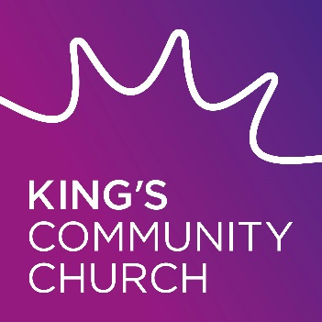
King’s Money Advice

Service

King’s Money Advice provide a free, confidential debt and budgeting advice service regardless of your background or circumstances. It is supported by King’s Community Church, Norwich and Community Money Advice

Target Group

Residents of Norwich and surrounding area

Referral Process

Contact King’s Money Advice by telephone or email.

Locations

The King's Centre, King Street, Norwich, NR1 1PH
Also at The Venue, Norman Centre, Bignold Road, Norwich, NR3 2QZ

Contact Details

0800 970 9875 / moneyadvice@kingsnorwich.com

